Final exam q1

Mehrab Atighi

1/12/2022

# multivariate 2 final exam codes: qestion :4  
library(MASS)  
data = read.table("F:/lessons/Multi countios Variate2/data/data-jomjome.txt", header = T)  
  
head(data , 4)

## X1 X2 X3 X4 group  
## 1 131 138 89 49 1  
## 2 125 131 92 48 1  
## 3 131 132 99 50 1  
## 4 119 132 96 44 1

plot(data[,-5])

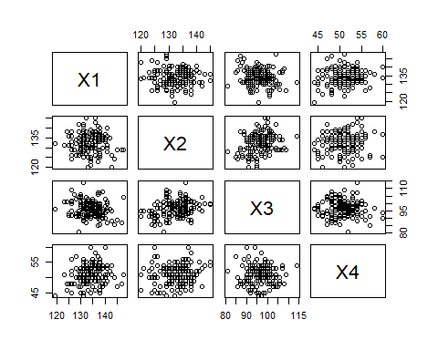

model1 = qda(data$group ~ . , data = data)  
model1

## Call:  
## qda(data$group ~ ., data = data)  
##   
## Prior probabilities of groups:  
## 1 2 3 4 5   
## 0.2 0.2 0.2 0.2 0.2   
##   
## Group means:  
## X1 X2 X3 X4  
## 1 131.3667 133.6000 99.16667 50.53333  
## 2 132.3667 132.7000 99.06667 50.23333  
## 3 134.4667 133.8000 96.03333 50.56667  
## 4 135.5000 132.3000 94.53333 51.96667  
## 5 136.1667 130.3333 93.50000 51.36667

pp = predict(model1)  
(t=table(pp$class,data$group))

##   
## 1 2 3 4 5  
## 1 12 8 4 2 2  
## 2 9 10 5 3 4  
## 3 3 4 8 2 5  
## 4 4 6 10 16 11  
## 5 2 2 3 7 8

(accuracy = sum(diag(t)) / length(data$group))

## [1] 0.36

(miss_err_classification_rate = 1 - accuracy)

## [1] 0.64

model2 = lda(data$group ~ . , data = data)  
model2

## Call:  
## lda(data$group ~ ., data = data)  
##   
## Prior probabilities of groups:  
## 1 2 3 4 5   
## 0.2 0.2 0.2 0.2 0.2   
##   
## Group means:  
## X1 X2 X3 X4  
## 1 131.3667 133.6000 99.16667 50.53333  
## 2 132.3667 132.7000 99.06667 50.23333  
## 3 134.4667 133.8000 96.03333 50.56667  
## 4 135.5000 132.3000 94.53333 51.96667  
## 5 136.1667 130.3333 93.50000 51.36667  
##   
## Coefficients of linear discriminants:  
## LD1 LD2 LD3 LD4  
## X1 0.12667629 0.03873784 0.09276835 0.1488398644  
## X2 -0.03703209 0.21009773 -0.02456846 -0.0004200843  
## X3 -0.14512512 -0.06811443 0.01474860 0.1325007670  
## X4 0.08285128 -0.07729281 -0.29458931 0.0668588797  
##   
## Proportion of trace:  
## LD1 LD2 LD3 LD4   
## 0.8823 0.0809 0.0326 0.0042

pp2 = predict(model2)  
(t=table(pp2$class,data$group))

##   
## 1 2 3 4 5  
## 1 12 10 4 3 2  
## 2 8 8 4 3 4  
## 3 4 5 15 7 4  
## 4 4 4 2 5 9  
## 5 2 3 5 12 11

(accuracy = sum(diag(t)) / length(data$group))

## [1] 0.34

(miss_err_classification_rate = 1 - accuracy)

## [1] 0.66